Web Application Maker
a model-based approach to web database development
Miguel Calejo, Mário Araújo, Sónia Mota Araújo, Nuno Soares
Declarativa, Application Infrastructure Group, R. Cerca 88, 4150-200 Porto, Portugal
Email: mc@declarativa.com, mfa@declarativa.com,sm@declarativa.com ,ns@declarativa.com
Keywords: web, RAD , declarative, model-based, interface generation, SQL
Abstract: Declarativa's Web Application Maker (WAM) is a software development tool to build and maintain web interface front-ends to relational database back-ends, using a model-based approach. To specify interfaces it pragmatically extends a mainstream database application model: the relational database schema itself. Interface generating capabilities are available to the application programmer at runtime, minimizing the traditional conflict between model-based and customized code. The initial WAM prototype supports Microsoft SQL Server and Active Server Pages, for Windows and Macintosh browsers, and is being used in several customer projects.

Introduction

What is it
The Web Application Maker (WAM) is a software development tool to build and maintain web interface front-ends to relational database back-ends, using a model-based approach. Whereas existing model-based user interface development environments are based on models invented or adapted specifically for the interface development process (see surveys [Griffiths et al 1998] [Silva 2000] for a surveys), WAM is pragmatically based on a mainstream database application model: the relational database schema itself.
WAM's innovation consists in the articulated combination of:
- Use of WAMmodel, a database resident declarative model based mainly on (a) dynamic introspection of the standard database engine's built-in meta-information, plus (b) a few complementary tables, thereby minimizing conflicts between database schema changes and application model changes
- Just-in-time generation of reactive user interface fragments (already including, for example, browser and server data type validation) from concise declarative specifications
- Making the GUI generating capabilities available to the application programmer at runtime for his/her customized code

This last aspect minimizes the traditional conflict between model-driven development and customized "handcrafted" code. Because in addition to encapsulating data editing/browsing functionality as in other GUI components, WAM runtime objects accept declarative (database) model references as method arguments, less verbose and minimizing code dependencies on database schema changes.
Web development, and in particular web database development, has made Meta programming a mainstream practice, as developers routinely produce single code fragments amalgamating diverse levels, referring database objects, web server objects and web client objects, such as in an Active Server Page (ASP) file [Microsoft 2001a]. But, no matter how much syntactic coloring and sugaring IDE editors provide, the result is an organized mess and a maintenance nightmare, as can be depicted for the ASP environment:
Figure 1: Typical web development

Although declarative object models are present in the browser and CGI layers, there's no use of the intrinsic DBMS model. The programmer fabricates SQL strings and gets back structured table/view results, but he/she must maintain the bindings with the other layers.
WAM simplifies the situation by introducing an extra Meta level whose domain of discourse is made of DBMS concepts, and by encapsulating code generation functionality into runtime reusable objects based on the application's data model:
Figure 2: Development with WAM

Iterative application development is based on pursuing two vectors of change:
- Enriching a simple meta-model, a set of database tables complementing the built-in meta-data of the database engine; and enhancing the database structure and stored procedures
- Higher-level and more robust ASP coding, as compared to current industry practice. The ASP development experience is significantly enhanced by the WAM system because it exposes the GUI database model-driven generation capabilities at runtime.
The initial WAM prototype supports Microsoft SQL Server 7.0/2000 and Active Server Pages, for Windows and Macintosh IE 4.x or later browsers. Pending on funding and/or customer pull, future versions may support alternative platforms at either of the database, web server or web browser layers. As of this writing WAM is already being used to generate whole or parts of most web pages in six customer projects of various dimensions, anywhere between 12 and 300 database tables. More details in [Calejo et al. 2001a]

The model-customization continuum
WAM allows a balanced use of modeling and coding (see [Calejo et al. 2001a] for concrete examples):
- Modeling alone allows the application to have significant GUI functionality
- An application with no scripting outside the database server will use the WAM-provided standard ASPs, and will reflect improvements to the database and/or the WAMmodel
- ASP scripting using WAM objects should delegate as much as possible GUI generation, to make code less brittle to database changes
- Scripting outside of WAM-generated pages can be invoked with WAMmodel specified links

WAM-based development does not fall in the extreme scenarios "use the model to generate the first version and then forget it because we need to change the code!" or "use an enormous model so we can always parameterize rather than code!" Instead, it supports a hybrid development style, fulfilling a continuum from one to the other extreme: the model-customization continuum, made possible by exposing to the developer the GUI generation facilities at runtime. This marries well with the dynamic nature of the web's GUI, but may also be applied in future WAM versions to other platforms such as Java's Swing.
The current WAM application GUI development process typically looks as follows:
- Design initial database including server procedures, user permissions, etc.
- Setup WAM and the (code free) web application, and get a working prototype immediately
- Iteratively edit the WAMmodel tables, develop customized and external ASP pages, improve database
- Pick or define a “pioneer user” within each user group, whose list preferences will be shared by others as a prototype
Future WAM versions will add steps to this process, namely WAMmodel-based automated regression testing.

GUI fragment | Description | Example
Row | A form to display/edit a record or view tuple | 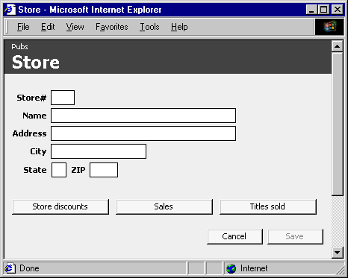
Lookup field | Displays a field in a related table; typically one or more lookup field appears next to the relating foreign key | 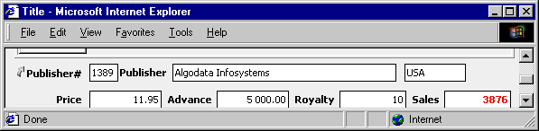
List | A form displaying a subset of a table, view or user-defined join, including user-defined sorting and navigation over the record set, possibly filtered with a search criterion, data exporting button, etc. | 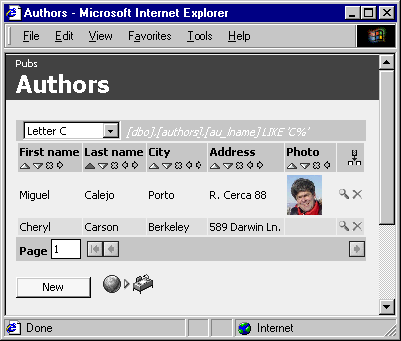
Criterion | A form to specify list filter criteria over the list table columns (a later WAM version also allows criteria with simple logical operators and over related tables) | 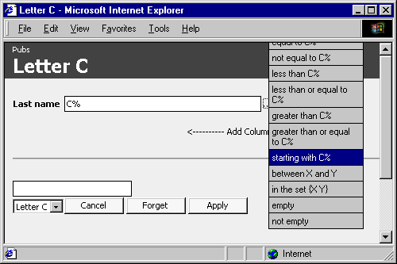
Figure 3: some WAM GUI fragments

Embedded (detail) list | Like a list, but restricted to the context of a related table; appears inside the master row | 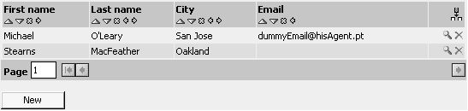
Standalone detail list | Like Embedded list, but appears in a standalone window, and includes a description of the related table context, using lookup fields | 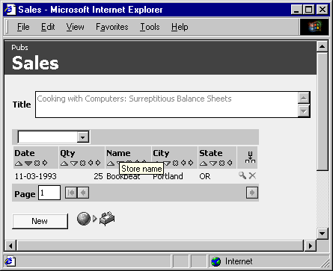
Procedure invoking button | A button which invokes either a database stored procedure or an external (ASP) page | 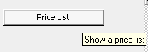
List set | A set of buttons to navigate to lists in the application
Finder | Similar to a row field, but providing quick search and navigation to a single tuple row or to a list | 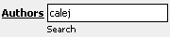

Figure 4: More WAM GUI fragments

WAM principles
This section contains a preliminary description of “WAM’s theory for GUI generation”. WAM and the enclosing web server can be seen as an interpreter for a theory on how to generate web pages from a WAMmodel instance, in answer to typified HTTP requests.
The current WAM version implements the principles below; future R&D will focus on better generation from the same or related database server information, cf. Future Work section.

GUI fragments/parts
WAM is essentially an application front-end fragment factory, which works based on minimal declarative specifications closely tied to the underlying (database) application. It serves a particular class of GUI front-ends, those interfacing database applications.
Because "all database GUIs are similar", at least to a certain extent, it is possible to identify recurrent fragments, each comprising GUI widgets, scripting, database access methods, error handling etc., cf. figure 3 and 4. In the next sections we'll see how WAM is guided to produce these GUI fragments.

Foreign key graph
The foreign key graph is an important piece of WAM’s conceptual background, namely because particular foreign key paths are used as names (hence generation specifications) of GUI fragments. It is defined as follows:
- Each table or view in the database originates a graph node
- Each relationship FK/PK between a table Detail with foreign key FK and table Master with primary key PK originates a directed edge from the Detail node to the Master node
- Each tuple in table WAM_Constraint_View_Usage originates a directed edge from its Detail_table (or view) node to its Master_table (or view) node; this WAM table allows the use of relationships involving views
We'll now introduce the WAM generation principles.

Database objects and how they impact GUI generation: GUI patterns
The previously defined GUI fragments can be used to solve database application design problems. In figure 5 we overview the "recipes" for solving these problems.
External presentation strings are absent from database engine meta-models, hence the central role WAM_PRESENTATION assumes in the WAMmodel.
Each line in the table in figure 5 can be seen as a "pattern", in the sense of [Patterns 2001], and so the whole can be seen as "WAM's GUI pattern catalog". We find this somehow related in spirit to efforts like [Coram and Lee 2001], the only GUI-related pattern language we found, although in our case with a more restricted scope - database applications.

Default inter-page Navigational Structure
A default navigational graph is offered to the user, taking into account database permissions, see [Calejo et al. 2001a].

Problem:  how to represent …/ how will … restrict the GUI | Solution:  recipes for GUI generation
Table or View | A table record can be visualized and edited in a row. Table records can be visualized and filtered in a list. A finder can provide simple front-end navigation.
Column | A row field, a list column, a looked-up column
Data type | Row field and list column validation, formatting
User-defined type | Special formatting, validation, user navigation (e.g. email, URL, image)
Primary key | Determines default auto-numbering policy, avoiding the need to fill the key fields
Constraint | Restrict edition at the GUI, introspect into admissible values
Permission | Hide or disable GUI objects and navigation links for a particular user or group
Foreign key, Foreign key path | Minimal specification of lookups, detail lists, user-driven joins in lists
Foreign key graph | Default navigational structure
Database objects have programmer names | Use a presentation function: WAM_PRESENTATION
Figure 5: WAM GUI generation recipes

Implementation
The WAMmodel for an application is defined as a set of VIEWs accessing the SQL Server intrinsic meta information for the application database and associated native objects (stored procedures etc.), plus a set of WAM tables with additional information. Although the application may use more than one database schema, it is assumed that it uses a single database (catalog). Here's a simplified diagram:

Due to space limitations WAMmodel details (tables, views, and user-defined types) can be found elsewhere, in [Calejo et al.2001b]. The same applies for the WAMLibrary API itself - ASP objects, standard pages, error handling, etc.

Conclusion

Comparison with other tools
This section attempts to position WAM regarding other tools. For a good overview of existing related tools see [Fraternali 99].
We're unaware of GUI generators pursuing such a close integration between their input (GUI specifications) and the back-end database applications they serve; to our knowledge all major commercial tools require human form/web page code revision if as little as a new single field is added to the database. Most provide (development time) wizards to generate code that can later be customized to a certain extent, but which is fragile against database schema changes. Such is the case for example for Macromedia Cold Fusion, Oracle Forms Services and Microsoft Access. ASP-DB [MMS 2001], a product whose purpose intersects WAM's, has the same problem, lacking any connection to the database engine meta-model. The same applies for "single-shot" code wizards such as Microsoft Visual InterDev's
Most research in the area proposes the use of higher level conceptual models, as basis for application generation, in complement or preceding the relational model. Such is the case for Araneus [U.Roma 2001], Autoweb [Fraternali et al. 2001], and Strudel [AT&T 2001], see [Griffiths et al 1998] [Silva 2000] for surveys. Given our lack of resources and focus on quickly developing practical solutions for customers it seemed preferable to embrace a pragmatic lower level model, closer to industry practice. Although our WAMmodel defines a few tables that must be filled "by hand", its core is simply the SQL DBMS own built-in Meta structure, always present and which may even be the output of higher level modeling processes, independently of WAM.
The software community has lately shown concern with "cross-dependencies", practical manifestations of higher-order concepts in the programmer's mind that are not properly captured into available programming abstractions such as functions, objects or rules. This is one of the main motivations for both Aspect Oriented Programming [Xerox 2001] and Intentional Programming [Microsoft 2001b]. WAM's pragmatic implementation of model-based web programming addresses a particular class of such cross-dependencies, namely those stemming from the multi layered nature of web program executors and the innate web structure dependencies from database models. And in fact we found thinking similar to ours in the description of a proposed application for Intentional Programming, cf. the "Scribble" example in [Simonyi 2001]. You can take WAM as providing a "web GUI front-end defining intention" for Transact-SQL programmers.

Performance
WAM is written in JavaScript accessing SQL Server, and at this time it takes around 1 second on a 1 GHz Pentium (web+SQL) server to deliver our testing benchmark to a browser in a LAN. This is a complex row form page with above average difficulty, taken from one of our customers: a table/view with 26 fields, 6 master lookups fetching additional fields, an embedded list, navigation to 4 detail lists and 7 buttons that call stored procedures and external ASPs. Which in practice means that we currently must use web server farms with 1 server per 2 or 3 simultaneous users. Given the low cost of each server this is not an immediate problem, but it currently confines WAM to intranet or low-traffic B2B projects.
The good news is that WAM is not optimized yet, as we've focused primarily on a clear and flexible implementation. In addition to compiling some critical ASP objects there are many opportunities for caching WAMmodel and interface data structures, at the SQL server and mainly at the ASP execution layer, for example by using Session cache variables. Another possibility for intranets is developing a Java client, within a traditional client-server architecture.

Future Work
At the moment we have many items in our to do list at various complexity levels; as until now WAM received no dedicated funding, priorities will naturally follow our customer project needs, but some issues stand out:
- Performance improvements, see "Performance considerations" elsewhere in this document
- Automated testing. We intend to adapt or develop a client-end testing tool to perform regression tests over (rolled-back) database states to ensure proper test context; we expect to be in a good position for this given the centralized information already available in the WAMmodel.
- Developer documentation and examples
Longer-term work involves detecting further high-level constructs in existing code representations, so as not to disrupt or change the developers way of working while speeding development. We've started to do it with our current use of the relational schema, but there's much more that can be done: relational databases encapsulate a lot of information that can be used beyond their immediate purpose.
For example, there's been work on reverse engineering relational into object oriented designs. With our experience a conjecture has emerged: detail lists should be embedded in their master's row if the primary key of the detail table includes the foreign key to the master and some other column(s). This happens to be the rule defined in [Ramanathan 1996] to identify aggregation, and naturally aggregated objects are better displayed in the same page. At the moment a WAM developer must specify that a detail list is embedded, in the future it will be done automatically.
Pending on funding to a proposed research project together with academic partners, we also hope to experiment using logic programming and learning techniques [Alferes et al. 2000] [Lamma et al. 2000] to reason on existing (hand-tuned) WAMmodels and application characteristics (those currently considered in WAM, plus SQL stored procedure and customized ASP analysis and others), in order to infer better WAMmodels for new application databases with less developer effort.
Finally, WAM addresses interface development for existing databases, not database design. Another dimension we'd like to explore is the incremental design of databases from higher level specifications, taking advantage of WAM's potential to quickly deploy an interface while possibly sharing linguistic and other knowledge.

References
AbsInt, "aiSee - Graph Visualization", http://www.absint.com/aisee/, May 29, 2001.
Alferes, J., Leite, J., Pereira, L., Przymusinska, H., Przymusinski, T., "Dynamic Updates of Non-Monotonic Knowledge Bases", The Journal of Logic Programming 45(1-3): 43-70, 2000
AT&T Labs-Research, "Strudel Web-site Management System", http://www.research.att.com/sw/tools/strudel/, May 29, 2001
Calejo, M., Araújo, M., Mota, S., Soares, N., "Web Application Maker - An Introduction", Technical Report, Declarativa - Serviços de Informática Lda. 2001a, http://www.declarativa.com/
Calejo, M., Araújo, M., Mota, S., Soares, N., "Web Application Maker - First Report", Technical Report, Declarativa - Serviços de Informática Lda. 2001b, http://www.declarativa.com/
Coram, T., Lee, J., "Experiences -- A Pattern Language for User Interface Design", http://www.maplefish.com/todd/papers/experiences/Experiences.html, May 29, 2001
Fraternali, P., "Tools and Approaches for Developing Data-Intensive Web Applications: A Survey", ACM Computing Surveys, Vol. 31, No. 3, September 1999
Fraternali et al., "Autoweb site", http://www.ing.unico.it/autoweb/, May 2001
Gamboa, T., "Towards the Development of Information Systems in Portuguese", MSc Thesis, Universidade Portucalense, Portugal, 1998
Griffiths, T., McKirdy, J., Forrester, G., Paton, N., Kennedy, J., Barclay, P., Cooper, R., Goble, C., & Gray, P., "Exploiting Model-Based Techniques for User Interfaces to Databases", in Proceedings of VDB-4, Chapman & Hall, London. pp. 21-46. 1998, http://citeseer.nj.nec.com/griffiths98exploiting.html
Lamma, E., Riguzzi, F., Pereira, L., "Strategies in Combined Learning via Logic Programs", Machine Learning 38(1/2): 63-87, January 2000
Major Micro Systems, "ASP-db, The Ultimate Web Database Tool", http://www.majormicro.com/asp-db7.html, May 29, 2001
Microsoft Corporation, "Active Server Pages", http://windows.microsoft.com/windows2000/en/server/iis/htm/asp/iiwawelc.htm, May 29, 2001
Microsoft Corporation, "Intentional Programming", http://research.microsoft.com/ip/, May 29, 2001
Patterns Home Page, http://www.hillside.net/patterns/patterns.html, May 29, 2001
Ramanathan, S., Hodges, J, "Reverse Engineering Relational Schemas to Object-Oriented Schemas", Technical Report MSU-960701, Mississipi State University, USA, 1996
Silva, P., " User Interface Declarative Models and Development Environments: A Survey", http://citeseer.nj.nec.com/359639.html, June 29, 2001
Simonyi, C., "Intentional Programming", http://research.microsoft.com/ip/mar99_files/frame.htm, May 29, 2001
U. di Roma Tre, "The ARANEUS Project", http://www.dia.uniroma3.it/Araneus/, May 29, 2001
Xerox PARC, "Aspect-Oriented Programming", http://www.parc.xerox.com/csl/projects/aop/, May 29, 2001

